

Government of Himachal Pradesh

HP SSO – Integration KIT (Himachal Pradesh- Single Sign On)
Document Control Information
Document Information
Document Name | Himachal Pradesh Single Sign On (Him Access Citizen)
Project Name | Himachal Pradesh Single Sign On
Client | Department of Information Technology, Government of Himachal Pradesh
Document Version | 2.0
Document Status | Final
Date Released | 31 December 2024
File Name | HPSSO Integration KIT

Table of Contents
- Introduction 1
  - Integrating using I-frame 2
    - End Points and Environments 2
    - Status Codes 2
    - Method Description 2
    - Process Involved 2

Introduction
Single Sign-On (SSO) application developed by the Department of Digital Technologies and
Governance, offers a plethora of benefits to the citizen of the State. Citizens can now access a wide array of Government services and Resources using a single set of login credentials, rendering the management of multiple accounts obsolete. This not only simplifies their interactions with the
Government Services and Systems but also saves time and resources, as they no longer need to create and remember multiple usernames and passwords.
Integration with the Single Sign-On (SSO) application developed by the Department of Digital
Technologies and Governance can offer several benefits to vendors or external service providers:
Streamlined Access: Vendors can streamline access to their services by leveraging the SSO platform.
Instead of requiring users to create separate accounts or undergo additional authentication
processes, vendors can allow users to sign in using their existing SSO credentials. This simplifies the onboarding process for users and encourages higher adoption rates for vendor services.
Improved User Experience: Integration with the SSO application enhances the overall user
experience for customers accessing vendor services. With SSO, users can seamlessly transition between different systems and applications without the need to repeatedly log in or manage multiple sets of credentials. This frictionless experience leads to higher user satisfaction and engagement with vendor offerings.
Enhanced Security: SSO integration reinforces security measures for vendor services by centralizing user authentication and authorization. By relying on the robust security protocols implemented
within the SSO platform, vendors can ensure that user credentials are securely managed and authenticated. This reduces the risk of unauthorized access or data breaches associated with traditional authentication methods.
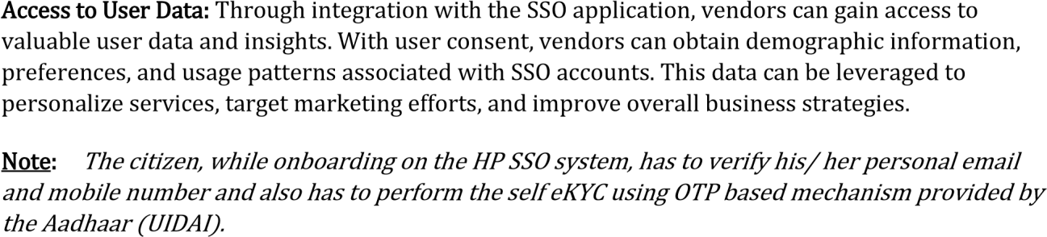

Integrating using I-frame

End Points and Environments

# | Environment Type | URL
1. | Production | Will be shared after successful integration in Pre-Production Environment
2. | Pre-Production | Will be shared after prior approval from concerned authority

Status Codes

# | Status Codes | Message
1. | 200 | Success
2. | 201 | Inserted Successfully
3. | 202 | Updated successfully
4. | 401 | Method Not Allowed
6. | 403 | Unauthorized

Method Description

# | Method | URL
1. | POST | https://preproduction_url/validateToken

Process Involved

Departments seeking to integrate with the Himachal Pradesh Single Sign-On (HPSSO) using the I frame method should follow these steps for effective implementation:

Script
Integration
Add HTML
Elements
Add Iframe
Button

Script Integration: Start by embedding a specific script into the website's header. This is accomplished by inserting the following script tag (The access to the Pre-Production and production will be granted after getting the necessary approvals:

<script src="https://pre-production-ulr:port/login.js" defer=""></script>

Next, add two crucial div elements to the HTML body of the page. These elements are:
<div class="backdrop"></div>

<div id="iframeContainer" class="iframe-container"></div>
Finally Create a button on the web page with an onClick event. This button should invoke the
getIframeSSO("service_id") function, which initiates the Iframe process. The "service_id" is a unique identifier for the department's service within the HPSSO system.

To receive user information, the following POST request is made on the specified URL:
# | Method | URL
1. | POST | https://preproduction_url/validateToken

Following are the parameters that needs to be sent in the Post Request
# | Mandatory (Y/N) | Parameters |  | Keys to Post | Data Type
 | Mandatory (Y/N) |  | Encrypted
1. | Y | token, secret_key | Yes | data | Encrypted String
2. | Y | service_id | No | service_id | String
When making a request, you'll need to post a JSON object (or form data) with two main parts:
The data key will contain the encrypted values of token and secret_key as a single encrypted string.
The service_id will be sent as a plain string.

# | Status Code | Response

1. | 200 | {  "data": "U2FsdGVkX1/ujtExWwdDv8VXvPszoidM3ykg="  }
2. | Decrypt data key using aes-256-cbc | {  "sso_id": 3669,  "vault_id": 0, "username": "****", "name": "***********", "mobile": "**********",  "email": *********@gmail.com, "gender": "Other",  "dob": "DD-MM-YYYY",  "co": "********", "street": null, "lm": null, "loc": "*****",  "vtc": "Shimla Urban(T)",  "dist": "Shimla",  "state": "Himachal Pradesh", "pc": "171001",  "UsersArray": [  {  "sso_id": "XXXX", "service_id": "XXXXXXXX",

"user_name": kushkumardhawan@gmail.com,

"mobile": "94596XXXXX",

"email": XXXXX@gmail.com, "primaryUser": false
}

],

"aadhaarNumber": "U2FsdGVkX18k31NbOOTCg+zh7Iva3tC9oTRLBq+Gdo Y=",
"education": [
{
"sso_id": "",
"qualification_level_id": "",
"qualification_id": "",
"specilisation_id": "",
"board_university": "",
"institution_name": "",
"subject_opted": "",
"result_status": "",
"passing_year": "",
"certificate_no": "",
"certificate_issue_date": "",
"certificate": "",
"percentage_marks": "",
"valid_date": "",
"qualification_level": "",
"qualification": "",
"specilisation": ""
}
],
"WorkExperience": [{
"sso_id": null,
"job_title": "",
"company": "",
"location": "",
"employment_date": null,
"employment_end_date": null,
"employment_type": "",
"description": ""
}],
"Skills": [{
}]
}
3. | 500 | {"error”: “Invalid Secret Key or service_id  /token."}
4. | 404 | {"error":" Valid token required"}

Him Access - Link/Merge Confirmation

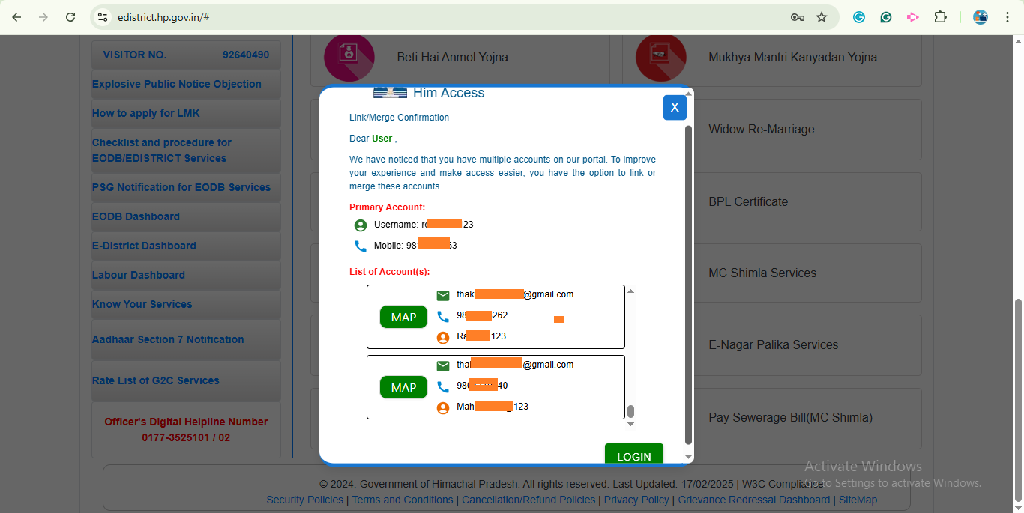

The Account link/merge feature is designed to help users manage multiple registered accounts. This functionality enables users to merge or link different accounts associated with their credentials, ensuring a more streamlined and hassle-free login experience. By consolidating multiple accounts into one, users can access all services through a single set of login details.
When a user logs in and the system detects multiple accounts linked to the same identity (such as the same mobile number or email), the interface prompts them with an option to merge these accounts. The primary account is displayed along with its username and mobile number. Below it, other associated accounts are listed, each showing email IDs, mobile numbers, and other relevant details. Users can choose to map these accounts by clicking the MAP button.
Once the accounts are merged successfully, the user can log in with a unified profile, avoiding confusion caused by multiple credentials. This feature enhances security, reduces duplication of accounts, and simplifies access to government services available on the portal. It is a user-friendly approach to ensure smooth and efficient digital service management.
To enable this mapping facility, we require an API from your end that provides user credentials.
The API must have the following parameters:
- Username
- Password (if encrypted, then please share the decryption algorithm)
- Mobile or E-mail

This API will help us merge multiple accounts into a unified single login system. By integrating this, users will have seamless access to all linked accounts under one login.

